Evaluating Tokenisation Efficiency for Sanskrit

Abstract
Sanskrit Digitalisation – last decade. Tokenization first task towards creating LLM.

Introduction
Tokenization efficiency matters because transformers scale with token count:
$$O\left(n^{2}\right)$$
More tokens:
- more attention cost,
- more VRAM,
- slower inference,
- shorter effective context.
That is why Indic tokenization quality is a serious engineering problem.

Background

Tokenization Methods/ Related Work

Vocab size is a hyperparameter. The underlying dataset is also a hyperparameter. Also, the length of the dataset interacts with the vocab size.

Intrincis / extrinsic evaluation
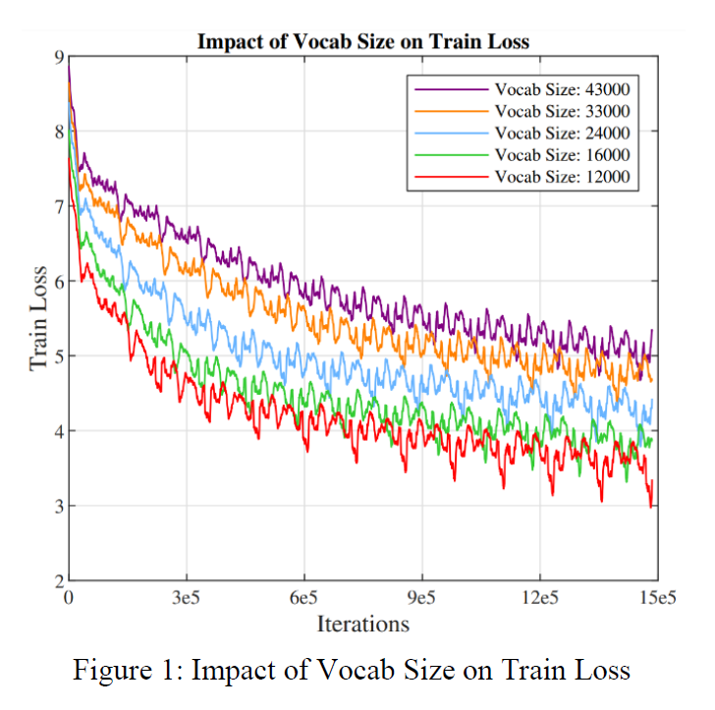

Dataset
Cleaned: https://github.com/sriramanved/itihasa_expanded_cleaned
citation: @inproceedings{aralikatte-etal-2021-itihasa,
title = "Itihasa: A large-scale corpus for {S}anskrit to {E}nglish translation",
author = "Aralikatte, Rahul and
de Lhoneux, Miryam and
Kunchukuttan, Anoop and
S{\o} gaard, Anders",
booktitle = "Proceedings of the 8th Workshop on Asian Translation (WAT2021)",
month = aug,
year = "2021",
address = "Online",
publisher = "Association for Computational Linguistics",
url = "https://aclanthology.org/2021.wat-1.22",
pages = "191--197",
abstract = "This work introduces Itihasa, a large-scale translation dataset containing 93,000 pairs of Sanskrit shlokas and their English translations. The shlokas are extracted from two Indian epics viz., The Ramayana and The Mahabharata. We first describe the motivation behind the curation of such a dataset and follow up with empirical analysis to bring out its nuances. We then benchmark the performance of standard translation models on this corpus and show that even state-of-the-art transformer architectures perform poorly, emphasizing the complexity of the dataset.",
}

“We used the cleaned Sanskrit corpus from itihasa_expanded_cleaned, a preprocessed fork of the original Itihasa dataset.”
The data is not a list format. It is a string format. Later converted into strings for ease of analysis.

Tokenisers

- cl100k base: The legacy tokenizer for OpenAI GPT-3 and GPT-4 models
- o200k base: The tokenizer used in the latest models (GPT-4o), designed to improve multilingual. compression and reduce punctuation fragmentation compared to its previous version.
- sentence piece (Kumar 2026)
- SansGPT tokenizer (Chaudhari et al. n.d.)
- https://huggingface.co/Xenova/claude-tokenizer A 🤗-compatible version of the Claude tokenizer (adapted from anthropics/anthropic-sdk-python).
- openaccess-ai-collective/tiny-mistral
https://huggingface.co/openaccess-ai-collective/tiny-mistral https://huggingface.co/winglian
- TWO/sutra-mlt256-v2 (Bendale et al. 2024)
- diabolic6045/Sanskrit-Qwen2.5-7B-base
- diabolic6045/Sanskrit-English-qwen2-tokenizer https://huggingface.co/diabolic6045/Sanskrit-English-qwen2-tokenizer/blob/main/TECHNICAL_README.md
- "google/mt5-small" (Xue et al. 2021)
- "facebook/mbart-large-50" (Liu et al. 2020) (Tang et al. 2020) [check citations]

Evaluation Metrics

Intrincis and Extrincis evaluation

Difference between the two qwen Sanskrit tokenizers: multilingual/general tokenizers may poorly represent Sanskrit orthography

Refer Kumar and Tamang & Bora

Evaluation:
The evaluation table for each tokeniser contains the following:
Sentence to be tokenized, the decoded sentence, the similarity between the two (this checks if the tokenizers are working properly).
“1. Token Count: The total tokens required to represent a text. LLM training and inference costs scale
with sequence length, making this a direct factor for economic and computational cost. “num_tokens”
2. Characters per Token (CpT): A metric for information density. It shows the average amount of
text captured by a single token; a large value indicates higher compactness.
3. Tokens per Character (TpC): A metric for fragmentation. It quantifies the cost of representing text;
lower values indicate that the tokenizer is efficiently utilizing its vocabulary to represent the language.” (Kumar 2026)
4. Subword fertility is one such technique which measures the average number of tokens used per word. • higher fertility → more context consumption,
• fewer in-context examples,
• higher inference cost,
• poorer multilingual fairness (Singh et al. 2024).

Experimental Setup

Results and Analysis

Discussion

Conclusion

Bibliography
https://medium.com/@viveksilimkhan/large-language-models-for-sanskrit-part-2-088b4e8c39c3

Bendale, Abhijit, Michael Sapienza, Steven Ripplinger, Simon Gibbs, Jaewon Lee, and Pranav Mistry. 2024. “SUTRA: Scalable Multilingual Language Model Architecture.”
Chaudhari, Rhugved, Bhakti Jadhav, Pushpak Bhattacharyya, and Malhar Kulkarni. n.d. “SansGPT: Advancing Generative Pre-Training in Sanskrit.”
Kumar, Anshul. 2026. “Is Sanskrit the Most Token-Efficient Language? A Quantitative Study Using GPT, Gemini, and SentencePiece.”
Liu, Yinhan, Jiatao Gu, Naman Goyal, Xian Li, Sergey Edunov, Marjan Ghazvininejad, Mike Lewis, and Luke Zettlemoyer. 2020. “Multilingual Denoising Pre-Training for Neural Machine Translation.” Transactions of the Association for Computational Linguistics 8:726–42. doi:10.1162/tacl_a_00343.
Singh, Harman, Nitish Gupta, Shikhar Bharadwaj, Dinesh Tewari, and Partha Talukdar. 2024. “IndicGenBench: A Multilingual Benchmark to Evaluate Generation Capabilities of LLMs on Indic Languages.”
Tang, Yuqing, Chau Tran, Xian Li, Peng-Jen Chen, Naman Goyal, Vishrav Chaudhary, Jiatao Gu, and Angela Fan. 2020. “Multilingual Translation with Extensible Multilingual Pretraining and Finetuning.”
Xue, Linting, Noah Constant, Adam Roberts, Mihir Kale, Rami Al-Rfou, Aditya Siddhant, Aditya Barua, and Colin Raffel. 2021. “mT5: A Massively Multilingual Pre-Trained Text-to-Text Transformer.”

